Reasons to Join
- Meet new people
- Opportunity to serve
- Participate in fun activities
- Entertainment
- Citizenship in the community
- Personal growth
- Continuing education
- Leadership development
- Be informed and inspired

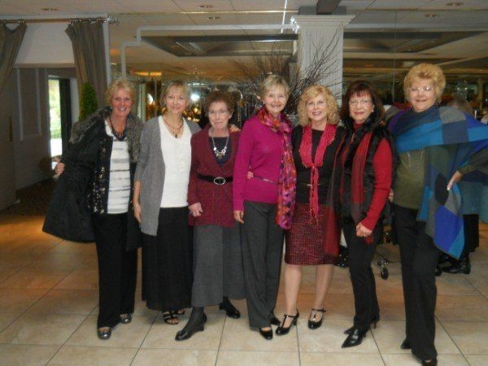
Following in Their Footsteps
On November 15, 1898, Mrs. L.D. Temple and thirty four women established “The Woman's Club of Flemington to promote the intellectual and social life of its members, to engage in philanthropic work as opportunity may present and for the general improvement of the Village of Flemington as to cleanliness of streets, promotion of literary interests, and every other thing tending to the advancement of
the best interests of the Village.”

The Club's interest in things literary started that first year: The club established a Reading Room for the public. The Free Public Library was then established in 1899. Also, in 1899, the club voted to join the New Jersey State Federation of Women’s Clubs which is part of the General Federation of Women's Clubs. In 1907, the club incorporated as the Flemington Woman's Club and purchased the lot behind the Old Courthouse on Park Avenue in Flemington. It is now a county park complete with bandstand and is the site of our clubhouse which was built in 1936.

Today, the Club continues the work of those thirty-four charter members who knew, over 100 years ago, the power of a determined woman, multiplied by hundreds. The women of the Flemington Woman's Club have supported their community for 100+ years.
The Flemington Woman's Club
43 Park Avenue
Flemington, New Jersey 08822
908-782-1237
Email: flemingtonwomansclub@yahoo.com
Visit us at: flemingtonwomansclub.org or Facebook.com/flemingtonwomansclub

Flemington Woman’s Club

An Invitation to Membership
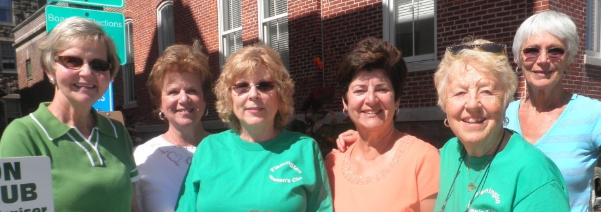
Working together in friendship, knowledge, and community service since 1898.
A member of one of the oldest, nonpartisan, nondenominational women’s volunteer service
organizations, the General Federation of
Womens Clubs

Welcome to the
Flemington Woman’s Club
Who Are We?
We are women of diverse backgrounds, ages and interests from Flemington and Hunterdon County. We raise money for scholarships, support community groups, and fund organizations and programs that provide education, comfort to the elderly and sick and essential services to our local population. Through our work together we form enduring relationships with each other and with those we serve.
We hope to see you at our monthly meetings. In addition to taking care of business, we always have an interesting program and a delicious tea! There are also various activities you can join such as Lunch Bunch and our Book Club.

What Are My Opportunities As A Member?
Participation
- Attend monthly meetings and special events
- Volunteer to help in a way that interests you
- Participate in one of our special interest groups
Support
- The FWC fundraising events
- Renew Membership dues ($55) in
January
Join a Committee
- Membership
- Hospitality
- Communications/Publicity
- Sunshine
- Fundraising
- Social Activities
Membership
By attending a meeting, it is our hope that you will enjoy the experience of being a part of our organization first hand. We meet at the Flemington Woman’s Club, 43 Park Avenue, Flemington, NJ on the second Wednesday of the month, September through May at 1 PM.

Affiliations
